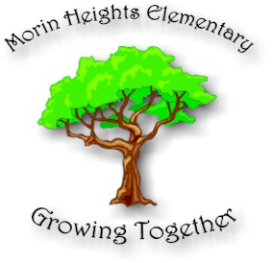
ANNUAL REPORT
This is an overview of the 2018-2019 School Year

Morin Heights Elementary School
647 rue du Village
Morin Heights, Qc

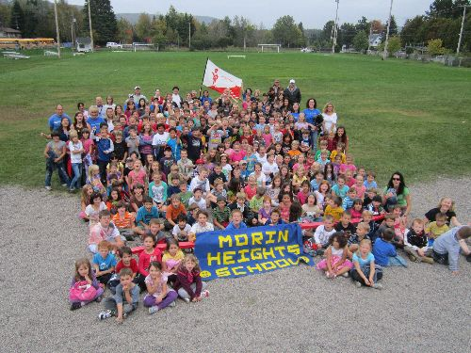

MHES Governing Board
2018-2019 Members
Parents
Cindy Angelini (Chairperson)
Kim Kasprzyk
Daniel Ryan Stone
Stacey Goodman
Sharon Candfield
Kathleen Maurice
Staff
Mary Antioco
Kelly Fahey
Elaine McDonald
Ryan Whitehouse
Tanya Conklin
Fiona Patulla
Community Representative
Patricia Rogers
Patricia Canty
Recording Secretary
Stéphanie Carrière
Our Mission - MHES is focused on creating a diversified learning environment that aims to stimulate and challenge the intellectual, moral, cultural, creative and physical development of our students with links to experiential learning in the outdoors, so that each child reaches their full potential in a caring bilingual milieu.
As we go through a school year, we provide diversified activities, guided by values and a vision that are believed to enrich the learning experience of MHES children with respect to academics, culture and sports.

MHES 2018-2019 Staff

Principal:
Tammie Marlin

School Secretary
Caroline Timmons

Kindergarten
Lisa Loveland
Marie Boivin

Cycle I
Kaitlyn Hellstrom
Lee-Ann Mascis
Janis Kelly
Esther Tousignant
Cycle II
Ilona Lajko
Bianca Stoico
Cycle III
Patrick Laverdiere
Elaine MacDonald
Kelly Fahey

Phys. Ed. & Health
Mary Antioco

Resource Teachers
Lise Gauvreau
Ryan Whitehouse

Special Education Attendants
Fiona Pattullo
Jane Waterman

School Daycare
Tanya Conklin (Natalie Gould)

Cafeteria
Angela Kowalyk
Tiffany Reader

Lunchtime Supervisors
Debbie Maurice
Lynda Osborne
Krystal Guilbeault
Natalie Gould
Tina Plouffe

Library
Jennifer Barnard

Caretakers
Robin Bowler
Craig Duguid/Adrian Horn

Behaviour Technician
Cindy Pachal

Non-teaching Professionals
Maria Guillen – Speech Therapist
Lina Ianni –Occupational Therapist
Natalie Gantcheff – School Psychologist

Another Successful Year!

In 2018-2019 special events and activities played an important role as they complemented our academic curriculum. Values of cooperation, tolerance, active participation, and positive involvement were practiced daily and were anchored by Respect, Responsibility, Safety and Empathy.

Daycare
Our MEES funded daycare program was open to students before and after school as well as on pedagogical days: our daycare attendance has improved this year but does not warrant a second educator on a full-time basis.

Welcome to Kindergarten Program
We used the Welcome to Kindergarten program to organize the kindergarten orientation day, which serves to inform and welcome incoming kindergarteners and their families.

Wellness- Oriented Program
Mindfulness Program: Daily Mindful moment and Zen den

We have implemented our Wild School Program in collaboration with the
Canadian Wildlife Federation:
- Inauguration of outdoor classroom
- Students prepared a Wild Fair to showcase their Wild School Projects for parents, and the community.

Health and Safety
Safety is always a main priority at our school. We also believe that healthy lifestyles and daily practices promote a readiness to learn. The following is a list of some of our programs that promote health and safety:
- Bus Safety Program
- Halloween Safety Program
- Fire Prevention
- Family Groupings
- Social Skills Programs with the Behavior Tech
- Dental Hygienist Visit
- Grade 4 Vaccinations

CLC (Community Learning Center)
Activities with Community:
Cozy Corners
MH Historical Society
MH Drama Association
MH Legion
4 Korners/ LESAN
More visibility in the community:
Melanie Bujold, Coordinator
sat on various MRC tables.

2018-2019 Activities
- Welcome Back Corn Roast
- Curriculum Evening(meet the teacher)
- Terry Fox Walk
- Breakfast Program
- Picture Day
- Scholastic Book Fairs
- Halloween activities
- Remembrance Day ceremony
- Running club
- Drama club
- Leadership program
- School Wide Christmas Concert
- Christmas Pajama breakfast
- Christmas bazaar
- Mini Basketball Tournament
- Intra-Murals
- Eagles Basketball Games
- Parent-Teacher Interviews
- Tell Them From Me Survey
- Student – led Conferences
- Wild Fair
- Choir (thanks to Shawna Dunbar- volunteer)
- Student Council meetings
- Award and closing ceremonies

Visiting Activities:
- Geordie Productions
- Tangage (Drug prevention &
High School Preparation)

Various field trips:
- Ottawa
- Water Park
- Domaine Vert
- Winter Survival
- Winter Activity Program
- Grade 6 High School Orientation
- Leadership retreats and summit

Our Students gave back to the community
- Terry Fox Run
- Christmas Basket Collection

Governing Board
The governing board is an important decision making body in our school and its members worked diligently to make decisions to seek continuous improvement on the quality of care and education within our school. This year, we met 5 times and the following are the highlights of main items that were discussed:

- Approved field trips
- Approved school rentals
- Oversaw budgetary needs, fundraising, and safety & security issues
- Adopted the existing subject-time allocation.

Parents Participation Organization
The generosity of our parent community continues to support the activity programs at MHES. Fundraising helps cover the cost of field trips, and in-school activities. The money raised is also used to fund other special purchases and or school – wide activities. Parent volunteers helped in the classrooms, on field trips and during the winter activity program.

PPO Fundraising Activities
- Christmas Bazaar
- Various fundraisers
Because of the diligence of our PPO members, our school also benefitted from many donations, both from individuals and corporations such as:
- Morin Heights IGA
- Desjardins Caisse de la Vallée
- Municipality of Morin Heights

And many more from community members who wish to remain anonymous…

Goals for 2019-2020

- Expand our “WILD” School Program with the help of our Canadian Wildlife Federation
- Become a Wild School that other schools in our board will visit to learn about nature and the outdoors
- Purchase more digital equipment to use as learning tools
- Professional Development in Coding and Technology
Respectfully submitted by Cindy Angelini, Governing Board Chair
Tammie Marlin , Principal

